Installing & Configuring Prometheus:

<https://devopscube.com/setup-prometheus-monitoring-on-kubernetes/>

<https://www.fosstechnix.com/install-prometheus-and-grafana-on-ubuntu/>

<https://blog.fourninecloud.com/what-is-prometheus-and-how-to-install-and-configure-it-on-linux-server-9b5f88685451>

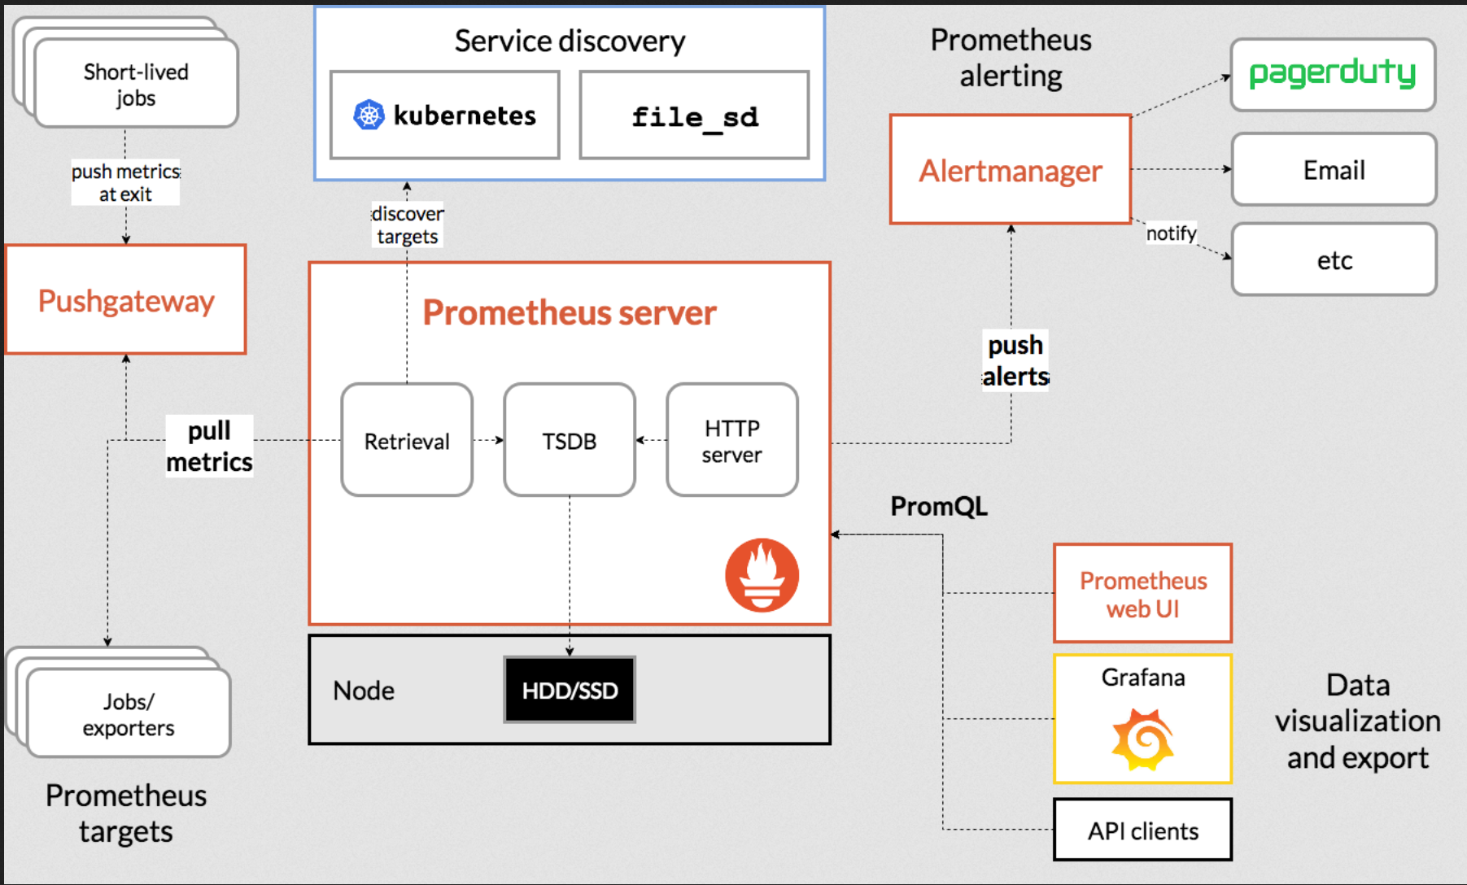

1. Deploy t2.medium ubuntu 20.04 server.
2. Perform following steps to copy binaries and permissions.

sudo useradd --no-create-home --shell /bin/false prometheus

sudo mkdir /etc/prometheus

sudo mkdir /var/lib/prometheus

sudo chown -R prometheus:prometheus /var/lib/prometheus

wget https://github.com/prometheus/prometheus/releases/download/v2.36.2/prometheus-2.36.2.linux-amd64.tar.gz -P /tmp

cd /tmp

tar xvf /tmp/prometheus-2.36.2.linux-amd64.tar.gz

sudo cp /tmp/prometheus-2.36.2.linux-amd64/prometheus /usr/local/bin/

sudo cp /tmp/prometheus-2.36.2.linux-amd64/promtool /usr/local/bin/

sudo chown prometheus:prometheus /usr/local/bin/prometheus

sudo chown prometheus:prometheus /usr/local/bin/promtool

sudo cp -r /tmp/prometheus-2.36.2.linux-amd64/consoles /etc/prometheus

sudo cp -r /tmp/prometheus-2.36.2.linux-amd64/console_libraries /etc/prometheus

sudo chown -R prometheus:prometheus /etc/prometheus/consoles

sudo chown -R prometheus:prometheus /etc/prometheus/console_libraries

ls -ltr /usr/local/bin/ | grep prom

1. sudo nano /etc/prometheus/prometheus.yml

global:

scrape_interval: 15s

scrape_configs:

- job_name: 'prometheus'

scrape_interval: 5s

static_configs:

- targets: ['localhost:9090']

1. sudo nano /etc/systemd/system/prometheus.service

[Unit]

Description=Prometheus

Wants=network-online.target

After=network-online.target

[Service]

User=prometheus

Group=prometheus

Type=simple

ExecStart=/usr/local/bin/prometheus \

--config.file=/etc/prometheus/prometheus.yml \

--storage.tsdb.path=/var/lib/prometheus/ \

--web.console.templates=/etc/prometheus/consoles \

--web.console.libraries=/etc/prometheus/console_libraries \

--web.enable-lifecycle \

--web.enable-admin-api \

--log.level=info

[Install]

WantedBy=multi-user.target

1. Start & Check Prometheus Status

sudo systemctl daemon-reload

sudo systemctl start prometheus

sudo systemctl enable prometheus

sudo systemctl status prometheus --no-pager

If you want to restart prometheus service

sudo systemctl daemon-reload

sudo systemctl restart prometheus

sudo systemctl status prometheus

1. Reload Prometheus Config Without Restarting Prometheus:

curl -s -XPOST localhost:9090/-/reload

1. Checking the process and port usage for Prometheus & Node Exporter

root@ip-10-40-1-10:/tmp# netstat -ltnp | grep -w ':9100'

tcp6 0 0 :::9100 :::* LISTEN 1629/node_exporter

root@ip-10-40-1-10:/tmp# netstat -ltnp | grep -w ':9090'

tcp6 0 0 :::9090 :::* LISTEN 1705/prometheus